GCSE courses
information booklet
For September 2020 entry
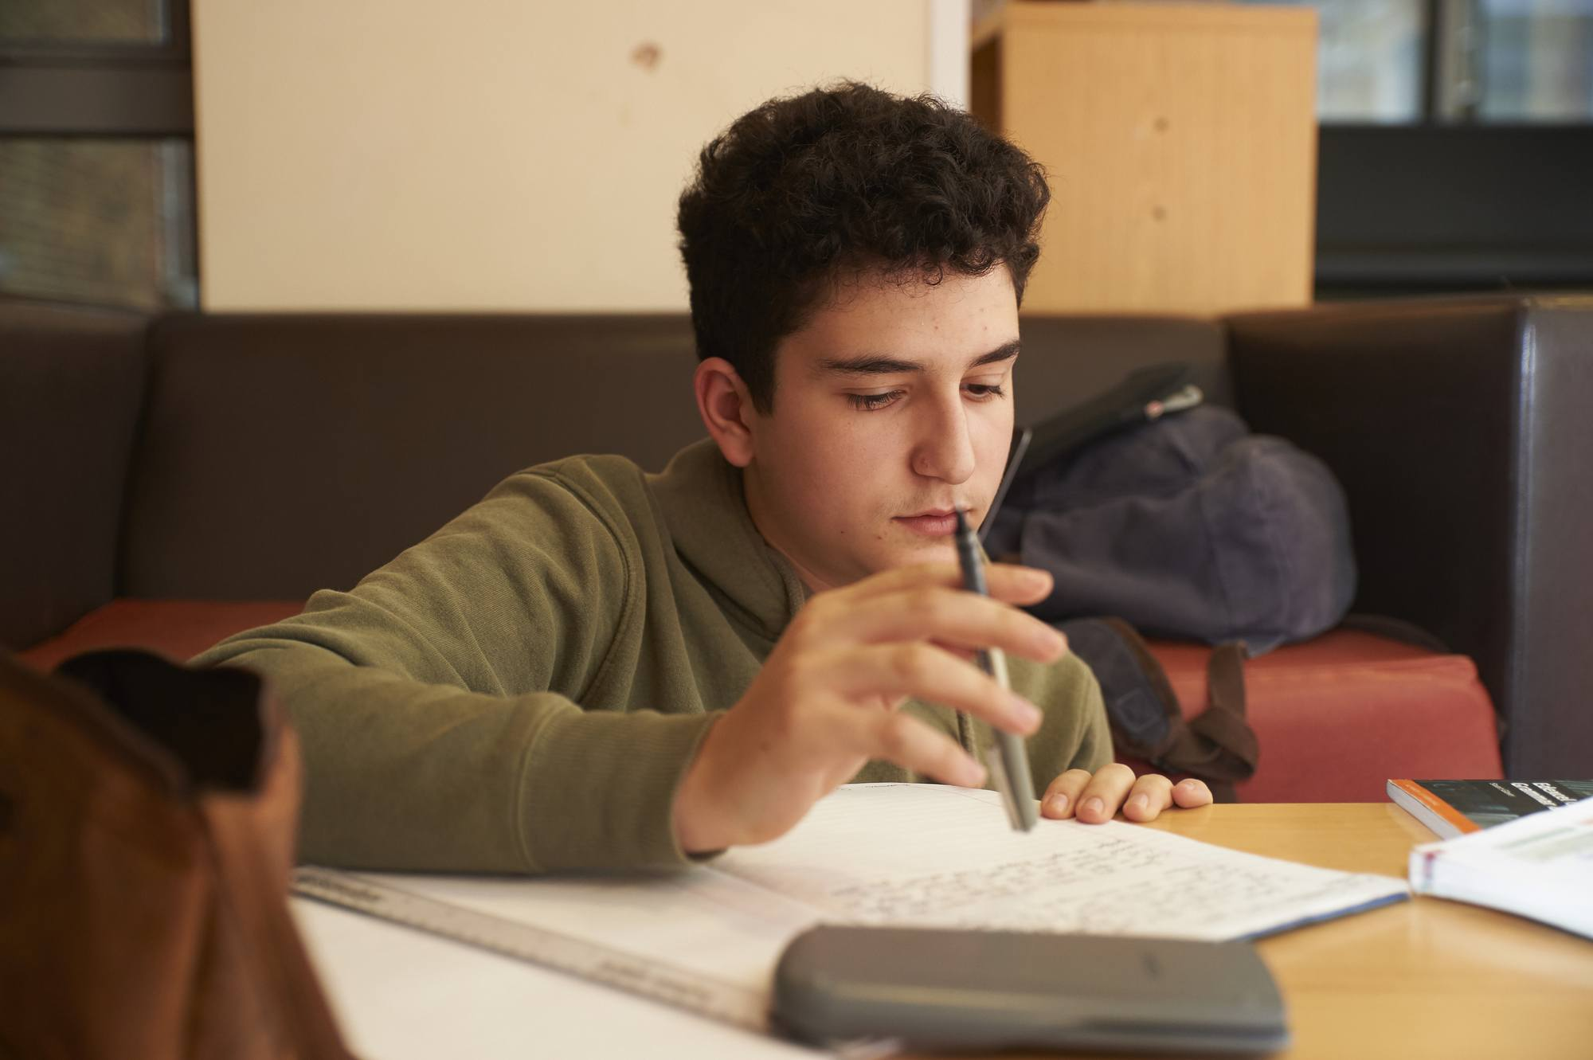

This booklet is designed to give you information on the GCSE and IGCSE courses offered at The Purcell School for study at Key Stage 4 (years 10 and 11). If you have any further questions, please speak to the appropriate Head of Department or subject teacher who will be able to give you more information.
Please also note that not all courses may run each year: the School may have to adjust the curriculum choices according to demand.
Foreword

Years 10 and 11 here at The Purcell School are unique.

Music lies at the centre of your work, with a multitude of exciting opportunities for you to deepen your performing skills and to gain a wider understanding of repertoire. Music in the classroom is endorsed by taking an IGCSE in Music at the end of year 10. This early IGCSE enables you to gain valuable and confidence-boosting experience of exams, helping you to prepare for year 11. In year 11 classroom music, you will develop your understanding of outreach education projects, composition, music technology as well as strengthening crucial skills in aural.

Most Purcell School students take a total of seven or eight GCSEs / IGCSEs, fewer subjects than most students take at mainstream schools. This allows you time to focus effectively on your performance studies in music. Just as importantly, it allows you to focus on consistent quality in your GCSE and IGCSE results. You will be expected to achieve results which complement the quality of your work in music. Purcell School students do very well at (I)GCSE: for example, in summer 2019, year 11 students gained top grades (A*, A, 9, 8 and 7) in 52% of the exams taken. 82% of results were A* - B or 9 – 5. In the school’s history, students have successfully gained places at highly regarded universities, to study either Music or other academic disciplines, with a relatively small portfolio of excellent results: quality over quantity.

The curriculum in years 10 and 11 includes three obligatory subjects additional to Music: English Language, Maths and Science (Dual Award). In total your core curriculum will facilitate five (I)GCSE passes. You will therefore have to choose two or three additional subjects from this list: English Literature, French, German, History, Art and Drama. You are asked to choose no more than two subjects from Block A and no more than two subjects from Block B.

GCSE Option Block A |  |  | GCSE Option Block B
English Literature |  |  | History
French |  |  | Drama
German |  |  | Art

We would expect most students who have English as their first language to study at least one modern foreign language but French and German cannot be taken without a minimum of one year’s formal study prior to starting the GCSE course. You should pick subjects you know you would enjoy or can imagine enjoying and in which you would succeed in achieving a good grade. Bear in mind that some subjects have a large coursework component; others have more terminal exams. We want you to be happy with the idea of study for its own sake – no GCSE on its own is going to get you a job, but a good set of grades at GCSE will help to open doors and will look impressive when you start to make applications for conservatoire, university or other pathways.

We want your experience studying GCSEs and IGCSEs to be inspiring. As a musician, you will find that these classroom experiences provide a context in which your creative instincts and performing skills will grow and flourish. We expect you to commit to the very best results. Our hope is that whatever subjects you choose, you will find subjects that inspire you and help you to develop as a musician and a person.

Christine Rayfield, Deputy Principal

GCSE | Art and Design | AQA

If you enjoy being creative, want to increase your practical skills and improve your analytical, communication and research abilities, Art and Design is a great choice. The skills you gain make it a great complement to other subjects. Art and Design is a way of seeing things and making sense of the world around you.

Fine art explores ideas, conveys experiences or responds to a theme or issue of personal significance. The areas of study are very broad and our GCSE course provides students with the opportunity to work in a range of different media and processes in two and three dimensions. Lessons are taught so students get the opportunity to learn to work in new ways and improve their existing skills. Included in this course will be a chance to work within; drawing, printmaking (lino, etching, mono and screen printing etc.), painting (acrylic, oil and watercolour), sculpture (casting, clay, wire sculpting etc.) and photography & digital editing. Such flexibility allows for more freedom of expression, encourages creative thinking and problem solving.

What skills will you learn?

Alongside improving your practical expertise, you’ll learn how to:

- develop, refine and record your ideas;

- present a personal response that realises your intentions;

- improve your creative skills through the effective and safe use of media, materials, techniques, processes and technologies;

- successfully use visual language and the formal elements e.g. colour, line, form, shape, tone, texture;

- use drawing skills for different needs and purposes.

The teaching throughout the course aims to increase the confidence of pupils in the critical, practical and theoretical study of art, and design.

The course is divided into the following components:

Component 1: Portfolio of Work 60% of the overall grade. (Year 10 & Autumn term year 11) Students are required to submit a portfolio that comprises of a sustained project and a selection of further work which represents their course of study.

Unit 2: Externally Set Task 40% of the overall grade (Year 11 Spring & Summer terms). Students respond to their chosen starting point, leading to 10 hours of sustained focused study under exam conditions.

The following materials are issued and billed at cost: GCSE Art Pack (brushes, pencils, presentation portfolio, paints etc.) to enable pupils to work within school and at home), approx. cost: £43.

Visits to galleries and museums are an integral part of the programme of study for pupils to see existing work first hand, make notes and drawings. The cost of trips will be charged. It would be beneficial for pupils to have access to a digital camera, to use for photographing reference and source materials for projects.

Additional Information
For more information on the course:

https://www.aqa.org.uk/subjects/art-and-design/gcse/art-and-design-8201-8206/specification-at-a-glance

GCSE | Drama | Pearson Edexcel

Do you want to:
- develop your interest drama and theatre?
- work imaginatively and creatively as part of a group?
- learn about social, historical and cultural influences in the theatre?
- become competent in a range of practical, creative and performance skills?
- go to the theatre?
- take part in performances in different styles?
You need to be:
- committed to group work!
- imaginative and disciplined in your approach to lessons!
- willing to contribute physically and vocally to all lessons!

Component 1: Devising (non-examination assessment) 40% of the qualification – 60 marks
Content -
- Create and develop a devised piece from a stimulus.
- Performance of this devised piece or design realisation for this performance.
Assessment -
- Internally assessed and externally moderated.
- There are two parts to the assessment:
1) a portfolio covering the creating and developing process and analysis and evaluation of this process (45 marks, 30 marks assessing AO1 and 15 marks assessing AO4).
and recorded / verbal evidence (between 4–5 minutes)
2) a devised performance/design realisation (15 marks, assessing AO2).

Component 2: Performance from Text (non-examination assessment) 20% of the qualification – 48 marks
Content overview
- Students will either perform in and/or design for two key extracts from a performance text.
- Centre choice of performance text.
- Performer or designer routes available.
Assessment -
- Externally assessed by visiting examiner.
- Centres are free to cover the performance / designing of the two key extracts in any way.
- Performance / design realisation covering both key extracts is worth 48 marks.
- If two separate performances are done covering two key extracts, then each
Performance / design realisation is worth 24 marks.

Component 3: Theatre Makers in Practice (written examination: 1 hour 30 minutes) 40% of the qualification – 60 marks
Content overview
- Practical exploration and study of one complete performance text.
- Choice of eight performance texts.
- Live theatre evaluation – free choice of production.
Assessment overview
Section A: Bringing Texts to Life
- This section consists of one question broken into five parts (short and extended responses) based on an unseen extract from the chosen performance text.
- Performance texts are not allowed in the examination as the extracts will be provided.
Section B: Live Theatre Evaluation
- 15 marks, assessing AO4.
- This section consists of two questions requiring students to analyse and evaluate a live theatre performance they have seen.
- Students are allowed to bring in theatre evaluation notes of up to a maximum of 500 words.

Additional Information

For more information on the course:

https://qualifications.pearson.com/en/qualifications/edexcel-gcses/drama-2016.coursematerials.html#filterQuery=category:Pearson-UK:Category%2FSpecification-and-sample-assessments

IGCSE | English Language and English Literature | CIE
Students take either:
IGCSE English - Cambridge IGCSE English - First Language (0500)
or:
IGCSE English - Cambridge IGCSE English - First Language (0500)
and
IGCSE Literature (English) – Cambridge IGCSE Literature in English (0475)
IGCSE English:
The course enables students to:
- develop the ability to communicate clearly, accurately and effectively when speaking and writing;
- use a wide range of vocabulary, and the correct grammar, spelling and punctuation;
- develop a personal style and an awareness of the audience being addressed.
Learners are also encouraged to read widely, both for their own enjoyment and to further their awareness of the ways in which English can be used. The course also develops more general analysis and communication skills such as inference, and the ability to order facts and present opinions effectively.
Students take two terminal exams which focus on: extended reading passages and directed writing & composition.

IGCSE Literature in English:
The course enables students to read, interpret and evaluate texts through the study of literature in English. Students develop an understanding of literal meaning, relevant contexts and of the deeper themes or attitudes that may be expressed. Through their studies, they learn to recognise and appreciate the ways in which writers use English to achieve a range of effects, and will be able to present an informed, personal response to the material they have studied. The course also encourages the exploration of wider and universal issues, promoting students' better understanding of themselves and of the world around them.
All candidates take Paper 1 Poetry and Prose, and EITHER Paper 2 Drama, OR Paper 3 Drama (Open Text) and Paper 4 Unseen, OR Paper 3 Drama (Open Text) and Component 5 Coursework.

The English Language course has four periods a week and the English Literature course has two periods.
Textbooks and literary texts are billed to students.

Additional Information

For more information on the courses:

Cambridge IGCSE English - First Language (0500) –
https://www.cambridgeinternational.org/programmes-and-qualifications/cambridge-igcse-english-first-language-0500/

Cambridge IGCSE Literature in English (0475) –
https://www.cambridgeinternational.org/programmes-and-qualifications/english-literature-0475/
GCSE | French and German | Pearson Edexcel
If you enjoy communicating with other people, finding out about how language works and learning about different countries and cultures, studying GCSE French or German is an excellent choice. You need to have studied the language at Key Stage 3 or equivalent as this gives the necessary base for the GCSE course.

The examination course is varied, requiring various skills. For example, you will develop your ability to communicate in speech and writing, and to understand a range of authentic spoken and written material, including adapted literary texts. You will also develop your knowledge and understanding of grammar, and a greater awareness of various aspects of the culture of French and German speaking countries.

The examination course is based on five themes, studied in the context of both your home and target language countries:
- Identity and culture
- Local area, holiday, travel
- School
- Future aspirations, study and work
- International and global dimension
All this will be tested by a range of tasks including, for example, comprehension questions in both English and the target language, role play, translation from English into the target language, writing in both a formal and informal register.

The GCSE exam gives equal importance to all four language skills, all examined in May / June at the end of Year 11. Each unit can be taken at either Foundation or Higher Tier but it is envisaged that all pupils will aim for Higher, the timings of which are:

Unit 1 - Listening and Understanding 45 mins 25%
Unit 2 - Speaking 10-12 mins + 12 mins preparation 25%
Unit 3- Reading 1 hour 25%
Unit 4 - Writing 1 hour 20 mins 25%

Additional Information
For more information on the courses:
GCSE French:
https://qualifications.pearson.com/en/qualifications/edexcel-gcses/french-2016.html

GCSE German:
https://qualifications.pearson.com/en/qualifications/edexcel-gcses/german-2016.html

IGCSE | History | Pearson Edexcel

Paper 1: Depth Studies - Paper code 4HI1/01
Two ‘depth studies’ -
- Germany: development of dictatorship, 1918–45
- A world divided: superpower relations, 1943–72
assessment -
Students are assessed through an examination based on their selected depth studies.
Students answer two questions, one on each of the depth studies they have studied.
There are 60 marks available in total.
The examination lasts 1 hour 30 minutes.

Paper 2: Investigation and Breadth Studies - Paper code 4HI1/02
Two ‘investigation and breadth studies’ –
- China: conflict, crisis and change, 1900-89
- The changing nature of warfare and international conflict, 1919–2011
Assessment -
Students are assessed through an examination based on their historical investigation and breadth study in change.
Students answer two questions, one question on their historical investigation and one question on their breadth study in change.
There are 60 marks available in total.
The examination
1 hour 30 minutes.

Additional Information
For more information on the course:
https://qualifications.pearson.com/en/qualifications/edexcel-international-gcses-and-edexcel-certificates/international-gcse-history-2017.html

GCSE | Mathematics | Pearson Edexcel
The linear course of GCSE Mathematics is covered over a three-year period, starting in year 9. The course is assessed at the end of year 11 with the following examinations:
Tier | Type | Content | Weighting | Method of Assessment
Foundation / Higher | Non-calculator  1.5 hrs | Statistics and probability, Number and Algebra, Geometry & Measure | 33.33% | External marking
Foundation / Higher | calculator  1.5 hrs | Statistics and probability, Number and Algebra, Geometry & Measure | 33.33% | External marking
Foundation / Higher | calculator  1.5 hrs | Problem solving questions | 33.33% | External marking
tier | Grades available
Foundation | 1 - 5
Higher | 4 - 9

There is no coursework or controlled assessments to be completed. However, students will be tested on the quality of their written communication within their final examinations.
The examinations are 11/2 hours long for each of the Foundation and Higher papers. Candidates achieving a mark below the minimum for the award of the lowest grade in each tier will be ungraded. These tiers of entry allow a full and balanced opportunity for candidates at all levels of attainment to show what they know, understand and can do. We mainly enter pupils for the Higher Tier but some pupils will be entered for Foundation Tier where suitable. The tier of entry is finalised after the mock examinations in January of year 11.
GCSE classes are split into three sets based on their end-of-year 9 summer grade. This allows students to progress at a pace suitable for their ability and allows a tailored programme of study to build confidence and key skills before moving on to higher grade topics. Set changes are available at the end of every term and are based on the results of the latest mock assessments together with approval from the Head of Department.
Teaching is also supported by an online learning programme from the Edexcel exam board and the ‘mymaths’ learning platform. This allows students to have direct access to the scheme of work and video tutorials which is extremely useful in encouraging independent learning skills and supporting private study and revision.

Additional Information
For more information on the course:
https://qualifications.pearson.com/en/qualifications/edexcel-gcses/mathematics-2015.html
IGCSE | Music | CIE

This course is completed at the end of year 10
The Cambridge IGCSE in Music specification aims to:
- enable candidates to acquire and consolidate a range of basic musical skills, knowledge and understanding, through the activities of listening, performing and composing;

- help candidates develop a perceptive and critical response to the main historical periods and styles of Western music;

- help candidates to recognise and understand the music of selected non-Western traditions, and thus to form an appreciation of cultural similarities and difference;

- provide a foundation for the development of an informed appreciation of music;

- provide a foundation for further study in music at a higher level.

The course is divided into three components -
Component 1: Listening 40%

Students will be taught to recognise and describe a broad range of musical features and styles and study one set work.

Students will sit a 1-hour and 15-minute written paper which has four sections:

- Section A: Unprepared Western Repertoire. Students answer questions based on two extracts.
- Section B: World Music. Students will answer questions based on extracts from three pieces.
- Section C: Skeleton Score. Students will answer questions based on one extract. This will include simple rhythmic and/or melodic dictation.
- Section D: Set Work. Students will answer questions based on two extracts from the set work.

Component 2: Performing 30%

Solo performance. Students may perform one piece or two short, contrasting pieces.
Ensemble performance. Students may perform one piece or two short, contrasting pieces.
The total playing time should be between 5 and 10 minutes.

Overview of assessment: recordings of both solo and ensemble performances (on CD); scores.

Component 3: Composing 30%

One composition written in a Western, tonal style. This composition must be fully notated.
One composition written in a style of the candidate’s choice. Notation appropriate to the style should be used. Where staff notation is not used, a written commentary is also required.

Overview of assessment: recordings of both compositions (CD); scores for both recordings and a written commentary for composition 2, where required.

Additional Information
For more information on the course: https://www.cambridgeinternational.org/programmes-and-qualifications/cambridge-igcse-music-0410/
GCSE | Combined Science: Trilogy | AQA
The course enables students to complete an in-depth study of the three sciences and to attain two GCSEs at the end of the course. There are six papers: two biology, two chemistry and two physics. Each of the papers will assess knowledge and understanding from distinct topic areas.

Biology paper 1:
Biology topics 1–4: Cell Biology; Organisation; Infection and response; and Bioenergetics.
Written exam: 1 hour 15 minutes - Foundation and Higher Tier: 70 marks (16.7% of GCSE)

Biology paper 2:
Biology topics 5–7: Homeostasis and response; Inheritance, variation and evolution; and Ecology.
Written exam: 1 hour 15 minutes - Foundation and Higher Tier: 70 marks (16.7% of GCSE)

Chemistry paper 1:
Chemistry topics 8–12: Atomic structure and the periodic table; Bonding, structure, and the properties of matter; Quantitative chemistry; Chemical changes; and Energy Changes.
Written exam: 1 hour 15 minutes - Foundation and Higher Tier: 70 marks (16.7% of GCSE)

Chemistry paper 2:
Chemistry topics 13–17: The rate and extent of chemical change; Organic chemistry; Chemical analysis; Chemistry of the atmosphere; and Using Resources.
Written exam: 1 hour 15 minutes - Foundation and Higher Tier: 70 marks (16.7% of GCSE)

Physics paper 1:
Physics topics 18–21: Energy; Electricity; Particle model of matter; and Atomic Structure.
Written exam: 1 hour 15 minutes - Foundation and Higher Tier: 70 marks (16.7% of GCSE)

Physics paper 2:
Physics topics 22–24: Forces; Waves; and Magnetism and electromagnetism.
Written exam: 1 hour 15 minutes - Foundation and Higher Tier: 70 marks (16.7% of GCSE)

Additional Information
For more information on the course:
https://www.aqa.org.uk/subjects/science/gcse/combined-science-trilogy-8464/specification-at-a-glance

